E-Signing Documents via the Portal
*You must have a subscription to ftwPortal Pro to be able to have your portal user e-sign non-ftwilliam.com documents in the portal.
*#You must have a subscription to both ftwPortal Pro and Documents to be able to have your portal user e-sign ftwilliam.com plan documents published from the Plan Document module in the portal.
**You must have the “E-Signing Authorization” signed and submitted to support@ftwilliam.com, in order to have the Portal E-Signing feature enabled for your account (Please review our WhitePaper for additional information).
***You are only able to publish one document at a time to the portal for e-signing, unless you are using the batch PPA restatement tool.
****You are able to publish any form/document to the portal for e-signature.
Publishing a Document to the Portal for E-Signing from the Plan Document Module:
*#Please click here to see a demonstration of this process.
*#This process is similar to how you publish a document to the portal, but with a few important differences.
- Search for your plan.
- Select the “Plan Document” module.
- Check the box next to the document you wish to publish to the portal for an e-signature. 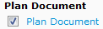
- Click on “Do with Selected.”
- Select “Publish to Portal” from the drop-down list. 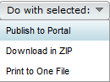
- Select your folder name from the “Folder” drop-down list (or type the folder name you wish to use into the field). * Note: this is optional.
- Check the box to indicate whether or not you would like to receive a confirmation email when the portal user downloads the file. *Note: if the Global Email Settings for the Document tab indicate “Editable” for the Confirmation Name and Confirmation Email, you may enter your own name and email address to receive the confirmation.
- Select a classification (or change the classification that is currently displaying) for the document. Note: if you have published the document from within the Plan Document module, the “Classification” and “Description” will default to the type of document you have published.
- Check the box to “E-Sign Document?” Portal users with the document classification of the document you selected, as well as the “Signing As” permissions of “Sponsor,” “Trustee” or “Sponsor/Trustee” will appear. If no portal users appear after checking the “E-Sign Document?” box, click on “Edit Portal Users” to review and/or update your portal user’s classification permissions and/or “Signing As” settings.
- You may select a portal user (or users) to be notified when the e-signing has been completed (for “View Only” permissions). If you do not wish to have a portal user notified and one is displaying, click on the trash can () next to the portal user’s name to remove the portal user from receiving a notification.
- If you would like the portal user to view the document after e-signing, you will need to make sure you allow him/her to have “View Access.”
- Check the box to add the document (for View Access) to your portal user’s To Do List. This is optional. If you have notifications turned on (Global Email Settings Screen-> Notifications tab), the portal user will be notified x number of days the item remains on his/her list. *Note: portal users with e-signing permissions will automatically have e-signing in their “ToDo List” once the document is published to their portal.
- Add an Expiration Date (optional) (for View Access). If you decide to add an expiration date, the document will be removed from your portal user’s portal once the date is reached and he/she will no longer be able to e-sign the document.
- Enter a Description. Note: if you have published the document from within the Plan Document module, the “Classification” and “Description” will default to the type of document you have published.
- Click on “Upload File”. Clicking on “Upload File” will publish the document to the portal. If you have the “Send email” box checked, you will be able to send an invitation to your portal user to access the document. Please click here to review a brief demonstration on the “Documents” tab of the “Global Email Settings” screen for additional information. *Once you have published the document to the portal by clicking on “Upload File,” the “E-Sign Document” checkbox will no longer be displayed, but you will see “Signing Information” which summarizes the following:
1. Portal user that is e-signing.
2. Whom the portal user is signing as.
3. The date the portal user was emailed, inviting him/her to e-sign.
4. The date the document was downloaded by the portal user prior to e-signing.
5. The date the document was e-signed.
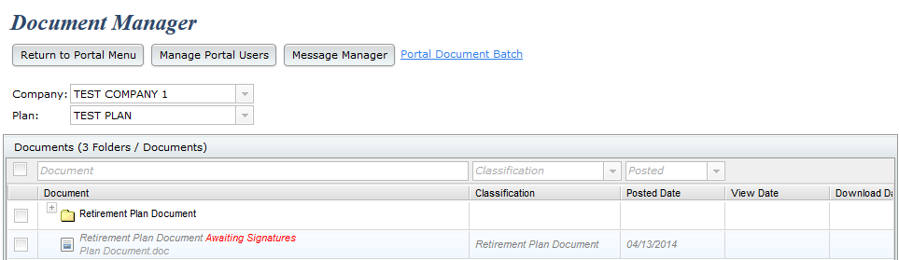
Additionally, if you click on your document name, you will be able to click on the “History” tab to see the signing information.
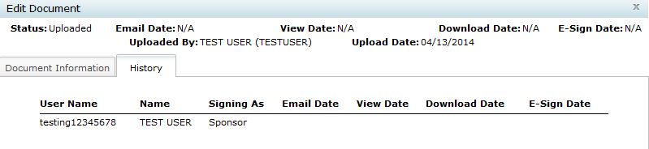
For the above screenshot, the only date that is displaying is the “Upload Date,” as the portal user has not logged into the portal yet to either view, download or e-sign the document.
Publishing a Document to the Portal for E-Signing via Document Manager:
*Please click here to review a demonstration of this process.
- Select “Document Manager” from the “ftwPortal Pro” drop-down list on the “Home” screen.
- Select a company and plan from the “Select a Company” and “Select a Plan” boxes. 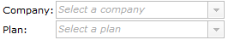
- Click on “Add New Document.”
- On the “Document Information” tab, complete the following entries:
  - Check the box if you wish to receive Download Confirmations. Enter your name and address into the “Override Name” and “Override Email” fields if editable (depending on your settings on the “Global Email Settings” screen-> Documents tab).
  - Check the box if you wish to add the document to the portal user’s To Do List.
  - Select an Expiration Date if desired.
  - Click on “Add Files” to add the file to be e-signed.
  - Enter a Folder name, or select a name from the Folder drop-down list.
  - Select the Classification.
  - Enter a Description.
  - Enter a Message.
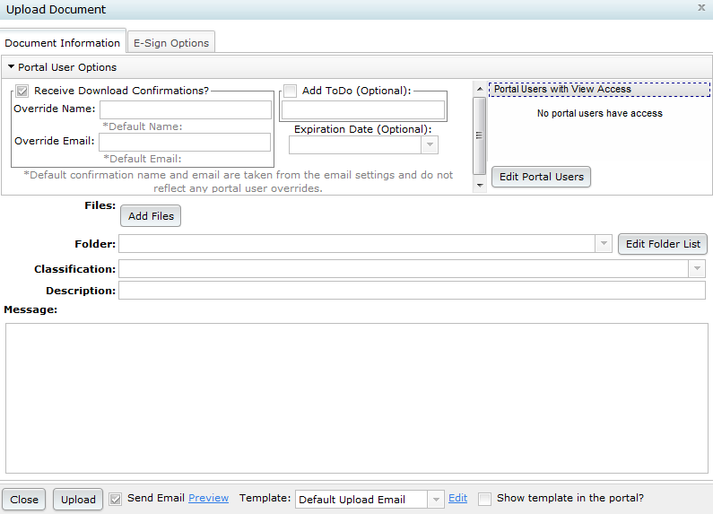
- Click on the “E-Sign Options” tab to complete the following entries:
  - Check the box to “E-Sign Document.”
  - Click on “Edit Portal Users” to edit/update a portal user to add him/her to the document to e-sign.
  - Click on “Add Portal Users” to add a portal user(s) you wish to be notified when the e-signing of the document is completed.
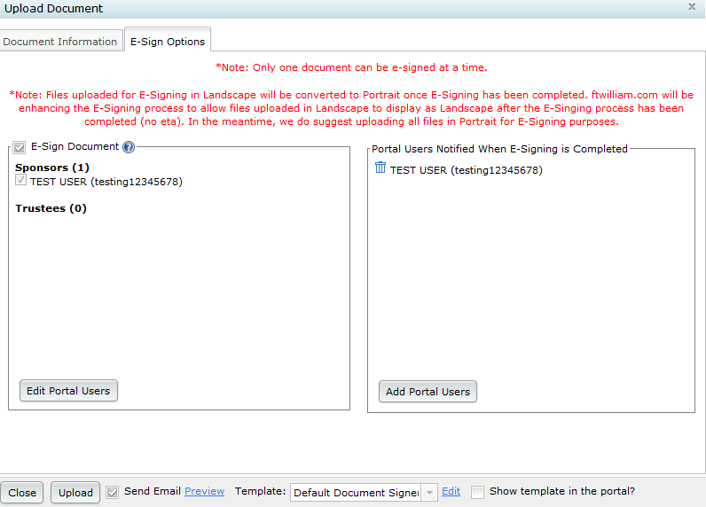
- Return to the “Document Information” tab.
- Check the box to indicate whether or not you wish to “Send Email” when you upload your document to be e-signed.
- If sending an email, select the template you wish to use from the “Template” drop-down list.
- Select whether or not you wish to display the email template in the user’s portal. If selected, the template will display when the portal user is viewing the document.
- Click on “Upload.” Clicking on “Upload” will send the document to the user’s portal for e-signing.
  - If you use “Preparer’s Email Program” as your email sending method, clicking on “Upload” will result in the following message displaying if you have the “Send Email” box checked:
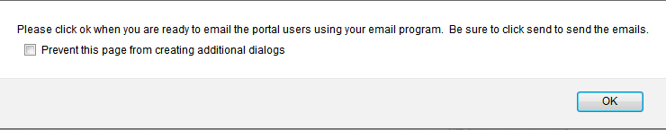Once you have clicked on “OK,” the email will display in your email program, to which you will click on “Send” to send the email.
  - If you use “Specify a Server” as your email sending method, clicking on “Upload” with the “Send Email” box checked will automatically send the email to your portal user.

Portal User E-Signing Procedures:
*Please click here to view a demonstration of this process.
*Note: this process is similar to the 5500 E-Signing procedures completed by a portal user.
- Click on the link contained within the Invitation Email you received.
- Enter your portal username and password on the portal login screen.
- Click on “Sign Document” on the left-hand side of the screen, or “Sign Document” which is displaying in the “To-Do List.”
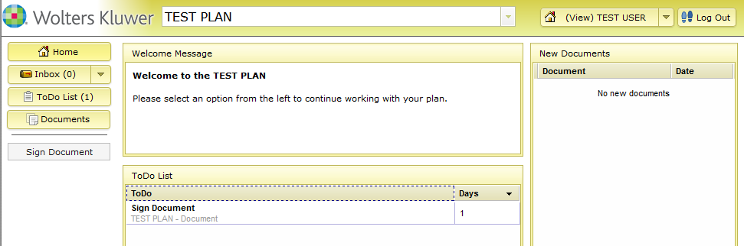
- You are now on the document signing screen.
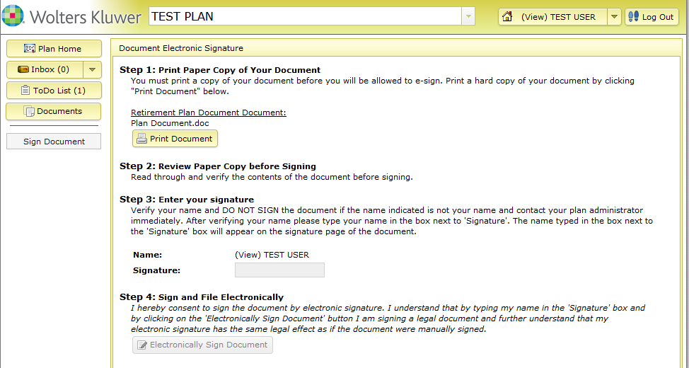
- Click on “Print Document”. *Note: in order to e-sign, you must print and review the document after you have clicked on “Print Document.” You will not be able to enter your name into the “Signature” field until you have clicked on “Print Document.”
- Type your name into the “Signature” field.
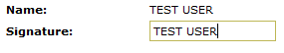
- Click on “Electronically Sign Document.” 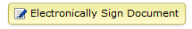
- After you have clicked on “Electronically Sign Document,” a pop-up will display, informing you that signing has been completed. You also have the option to view the signed document on this screen as well. If you click on “Click Here” on this screen, you will be able to download the signed document and click on “Signing Information” to view the signing details.

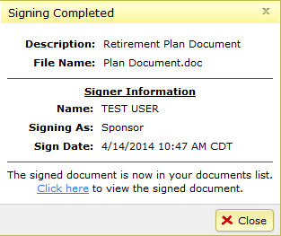

Your View Once the Portal User E-Signs the Document:
*Please click here to view a demonstration of this process.
*Note: you will not be able to view the signed document until all parties have completed signing.
- If set up, you will receive an email confirmation once the portal user downloads the document, as well as when the portal user e-signs the document.
  - The email confirmation you receive, once the portal user downloads the document, is sent from a donotreply@ftwilliam.com address and has the following in the email subject line: “(Document Name).doc has been Downloaded.”
  - The email confirmation you receive, once the portal user e-signs the document, is sent from a donotreply@ftwilliam.com address and has the following in the email subject line: “Signing Completed for (Document Name).doc for (Plan Name).”
- If you are viewing the Document List within “Document Manager” for the plan you invited to e-sign, you will be able to see the e-sign status. If the document is still awaiting a signature, “Awaiting Signatures” will display. If the document has been signed, “E-Signed” will be displayed.
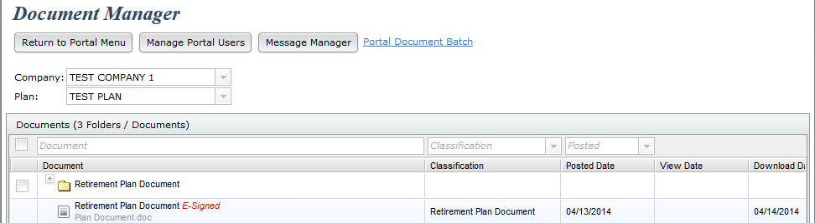
- Clicking on the document name within the “Document” column, will bring you back to view the “Signing Information” by clicking on the “History” tab and will also allow you to download a copy of the e-signed document.

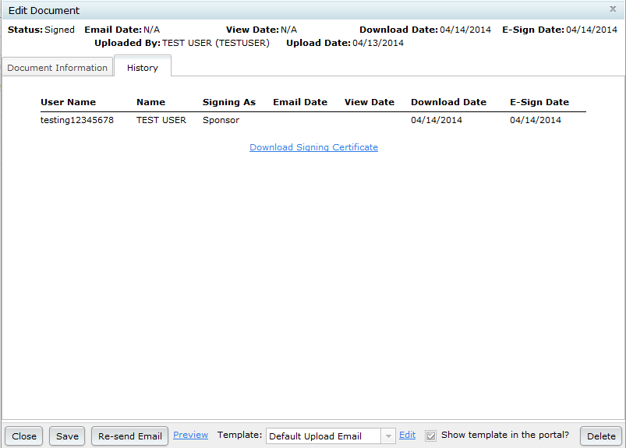

A “Signing Certificate” is also found on this screen (will display after you click on “Download Signing Certificate”), which is not made available to the portal user. You will be able to access this same information within the Plan Document module by clicking on “E-Signed Plan Documents,” clicking on the document name, then downloading the certificate.

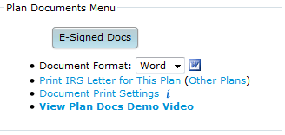

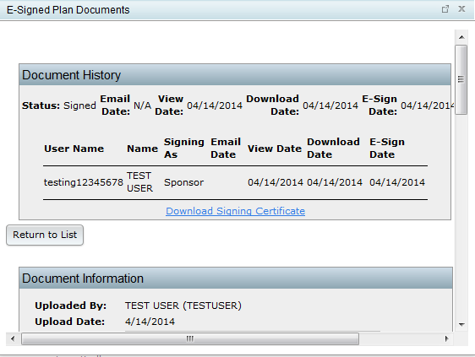

*The “Signing Certificate” will list each signer, whom he/she signed as, a signed date and a certification ID. In addition, there will be a signature block to indicate that ftwilliam.com is the software vendor. **Note: if you have a letter in your firm’s name, there will be a signature block for you to complete, instead of you seeing the “ftwilliam.com” signature block.

