Distribution Module User Guide

We developed this tool to enable creation of distributions for a participant by batch. This new tool will create Distribution, Fee, Forfeiture and Loan Default transaction batches based on your selection.
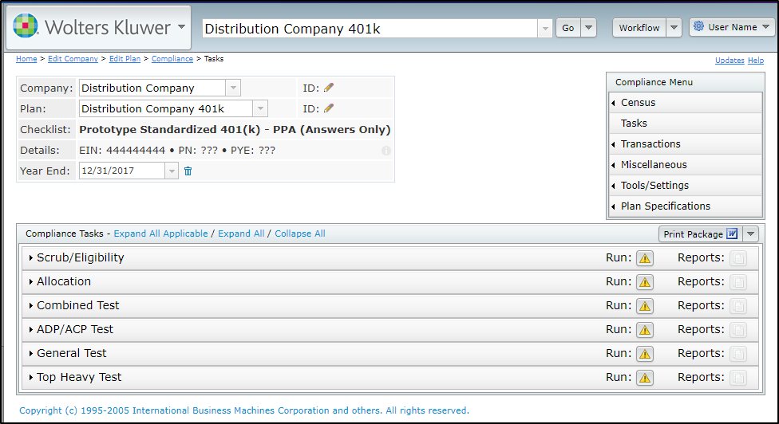

The first thing we’ll want to do is review plan specifications:
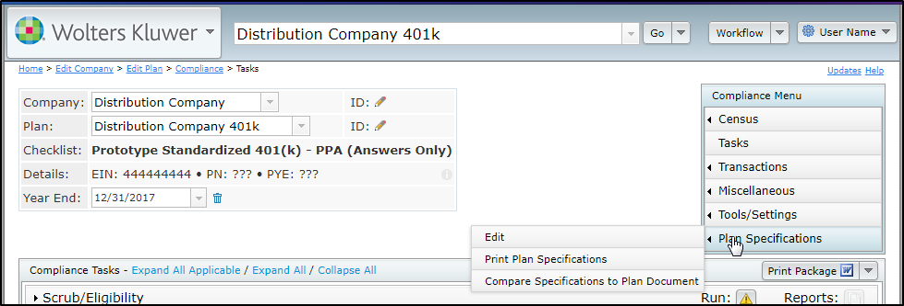

Select Work with Sources/Inv Accounts. 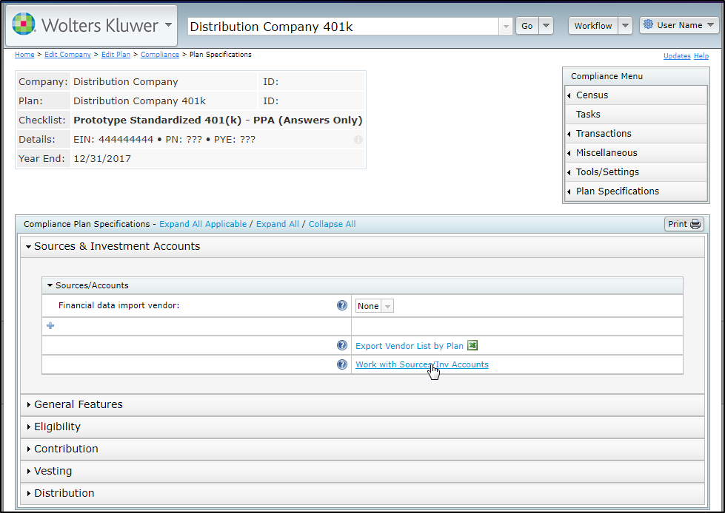
Select the link for Loan/Distribution/Fee Hierarchy, formerly Loan Hierarchy.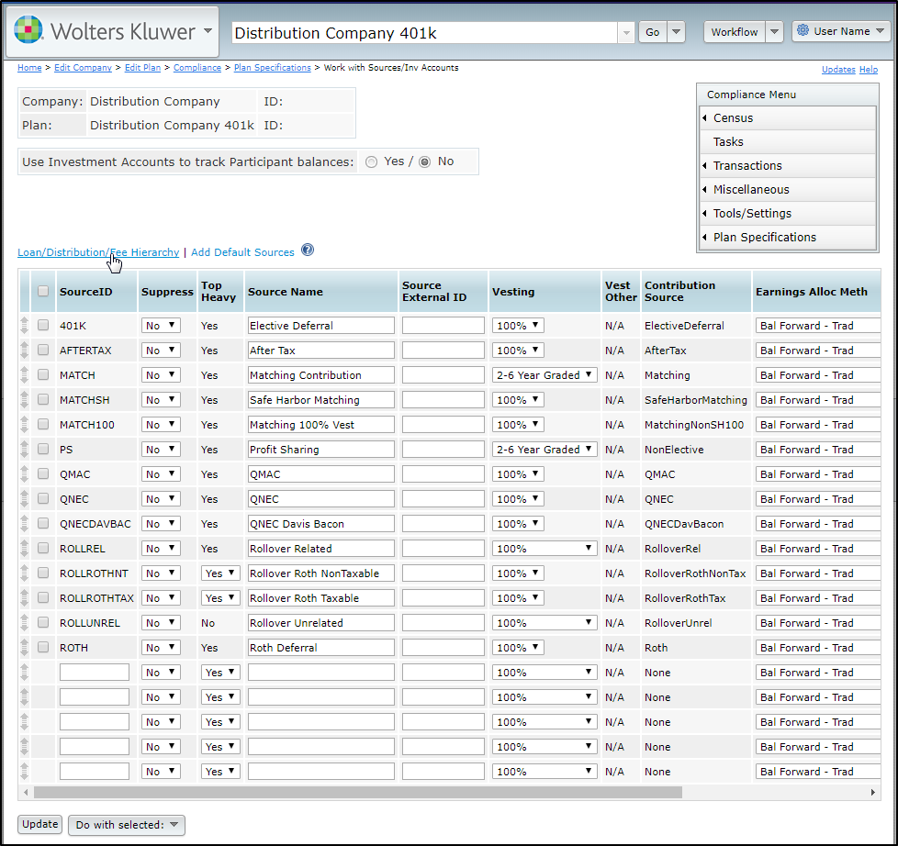
As you can see, we’ve added options for Fees, In-Service and Distribution.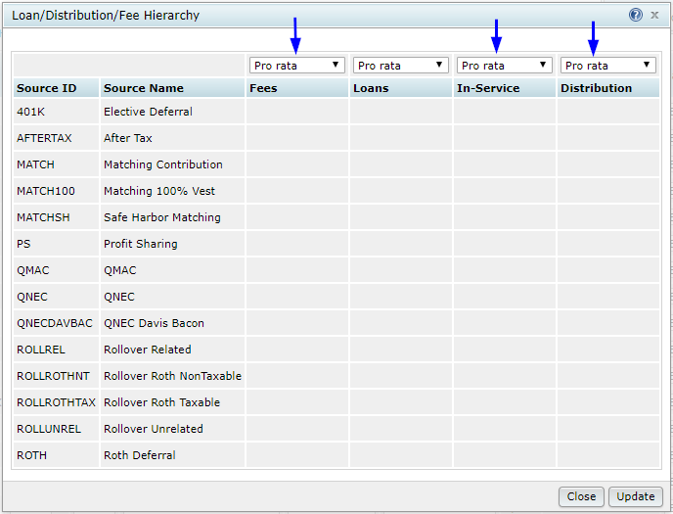

You can select Pro rata or Ordering rule. All plans have been defaulted to Pro rata so if this meets your needs simply select Update at this time.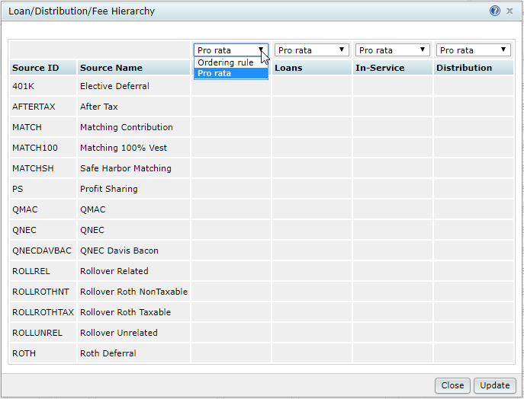
If your plan has excluded sources or uses hierarchy to determine the order sources are withdrawn, select Ordering Rule. Enter a number starting with 100 for each source you wish to include. Leaving a source blank when Ordering Rule is selected will exclude it from the transaction type. This feature works similar to the existing Loan functionality. Selecting Update will save your entries.
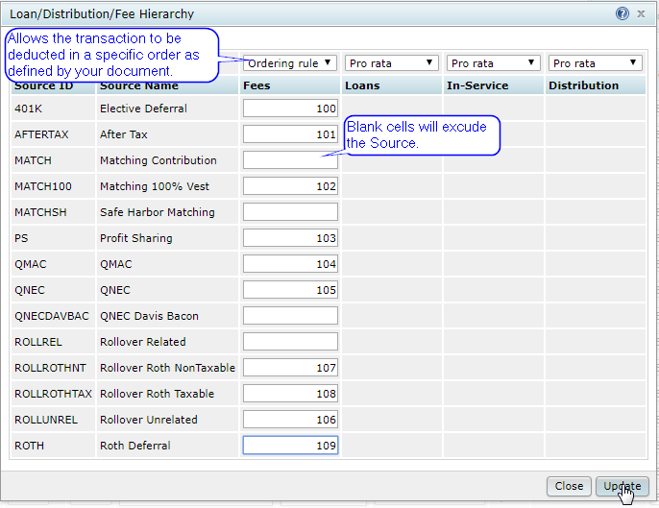

If you use investment accounts for your plan or use the Loan feature in Compliance, Use Investment Accounts to track Participant balances will be Yes. If it is No, you are done with Plan Specifications at this time. However, if it is Yes, you will want to select the Work With Investment Accounts link.
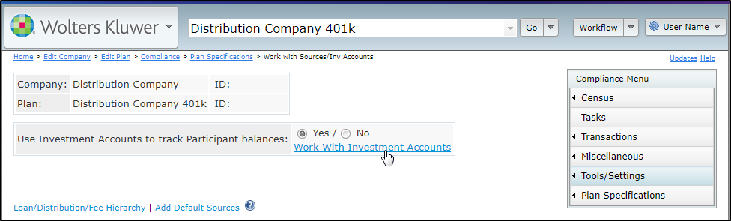

Then select Loan/Distribution/Fee Investment Hierarchy.
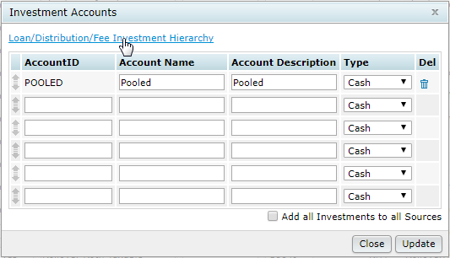

As you can see, we’ve added options for Fees, In-Service and Distribution here as well to allow control based on excluded investments or use of hierarchy. If there are no exclusions and Pro rata meets your needs, simply select Update at this time.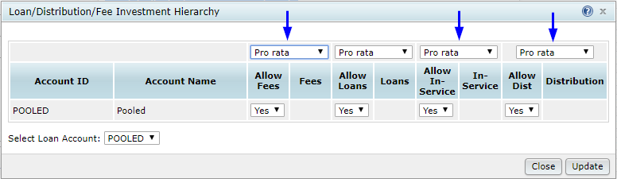

You can indicate which investments are excluded by Selecting No from the drop down under each transaction type and selecting Update once you are done.
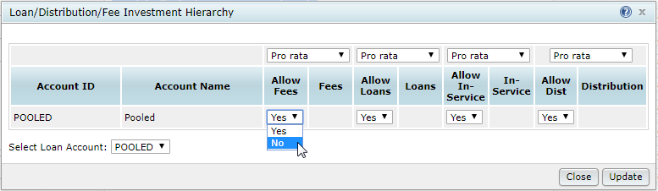

By selecting Ordering Rule, any investments that have not been excluded will allow for entry of a number starting with 100 for each investment to set the order it will be withdrawn. This feature also works the same as the existing Loan functionality. Selecting Update will save your entries.
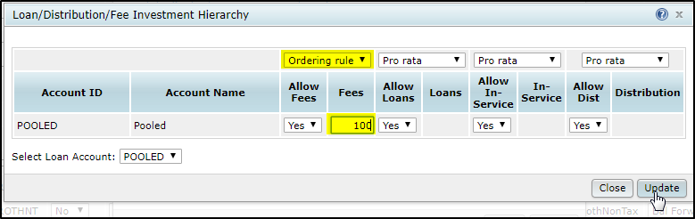

You can close out any open pop ups and navigate to the Compliance Menu. Select Transactions and Distributions.
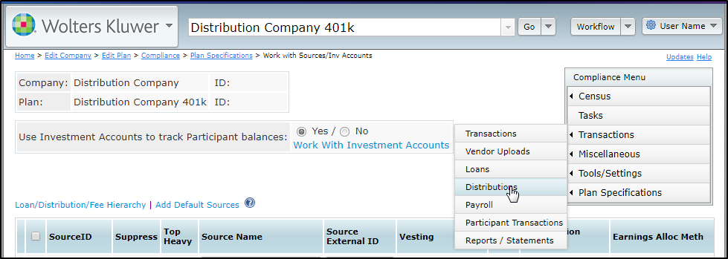

Once you are on the Distributions page you can select the link for Add New Distribution.
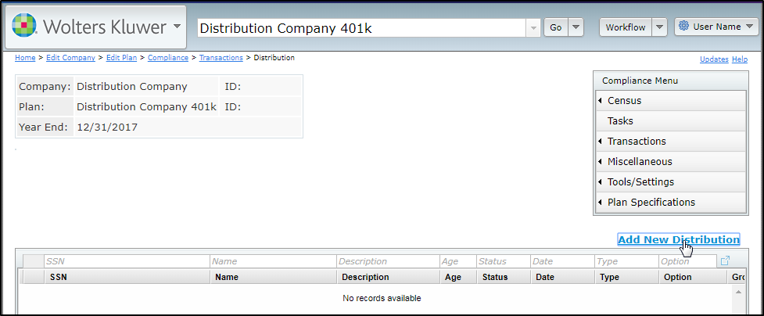

In the pop up, select a participant and add a description. When selecting a participant, if there are any pending distributions, they will appear below the description with a link to edit. 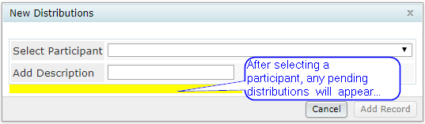

Once you have entered the information, you can select Add Record. The description can be anything you wish but must contain something in order to add the record. 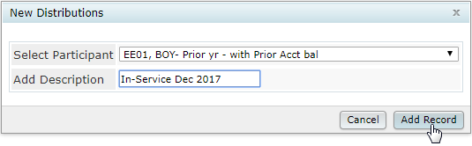

You will then be directed to a pop up to Enter Distribution Data for the Participant. 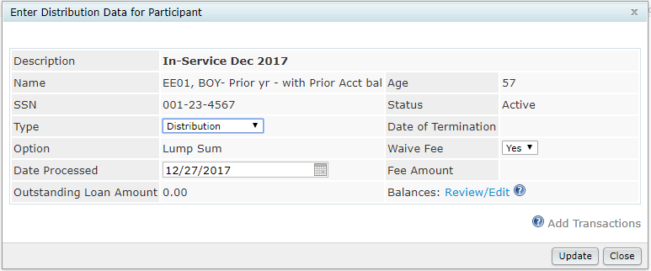

The Type defaults to Distribution, however, there are 2 options currently available: Distribution and In-Service/Partial. This selection determines whether the transaction batches will be Distribution or Inservice. We plan to add Hardship in the future. Status and date of termination are visible. To change them, you need to update your census data within the plan year end and run the scrub.
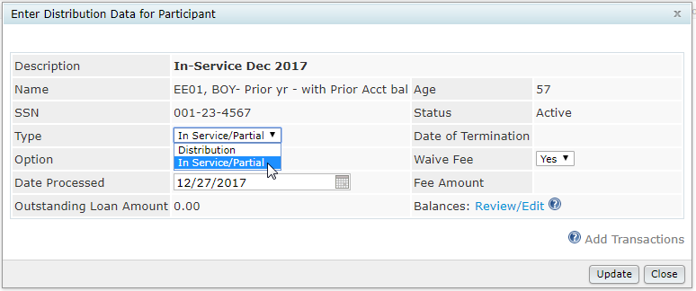

The date processed defaults to the current day. You will need to change this if you are processing for a different date. The Date processed must be within the PYE you are currently working within. 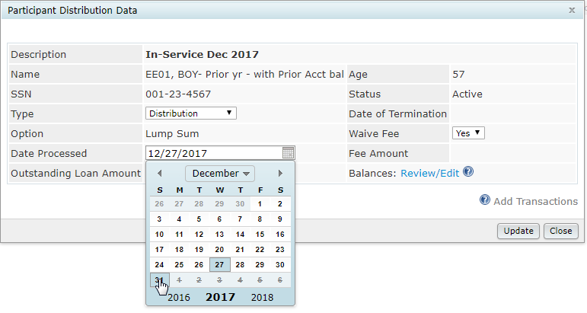

Waive fee is defaulted to Yes. If you wish to charge a fee, select No and enter an amount in the Fee Amount field.
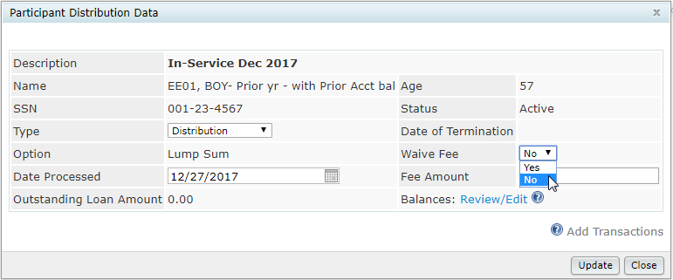
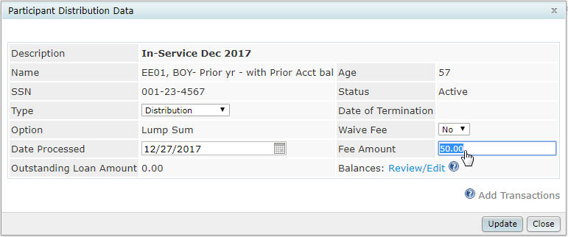

Once you have updated all the information, select update. Then select the link for Review/Edit. You will note that Add Transactions is not available at this time.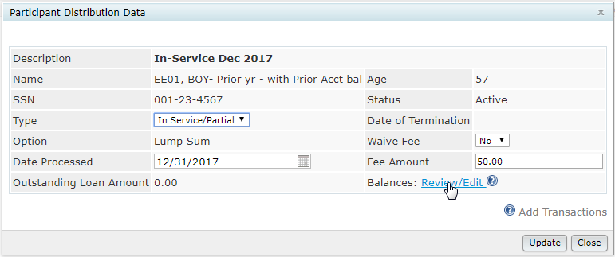

A pop up window will open to review Amounts Available for Distribution. The participant name and SSN appear at the top for convenience.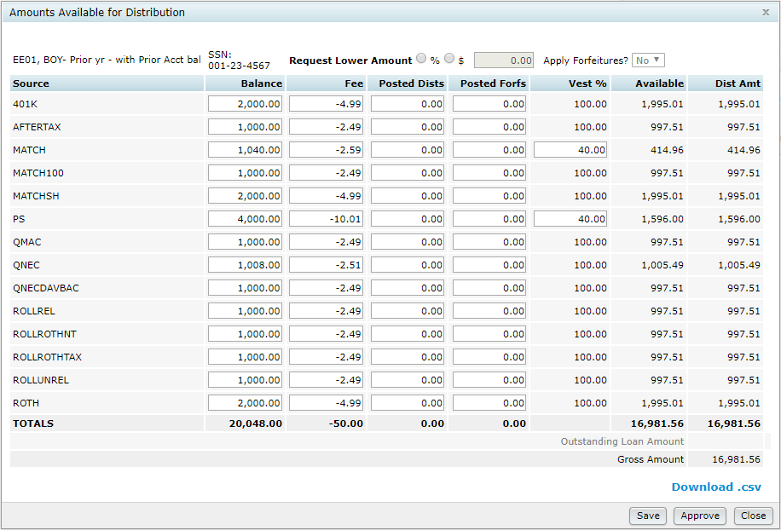

The Balance is collected from the end balance records for the current plan year end when the statements or participant summary are run. If this is a newly rolled forward plan year end and the scrub and statements have not yet been run, the system will search for the most recent past end balance and pull that forward. These fields can be edited if you have not been able to post all the necessary transactions but know the current balance. 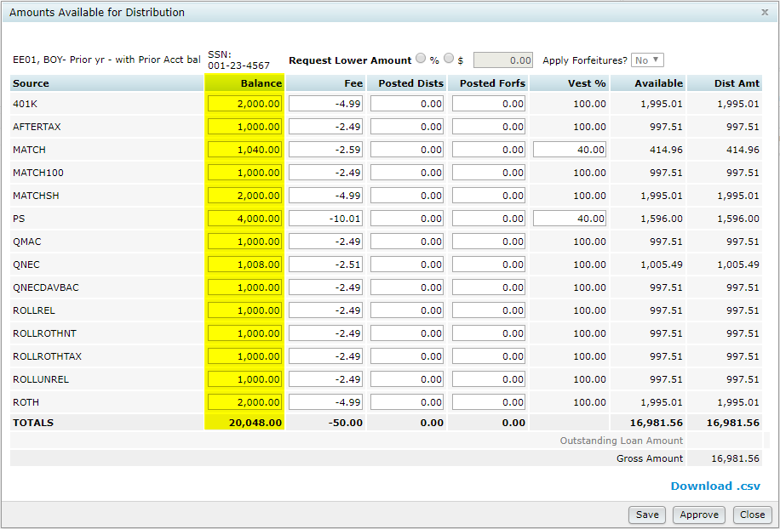

The fees are allocated based on the selections in plan specification we made earlier. This plan is pro rata so they are allocated based on the balances. These amounts will recalculate whenever you select save or make a change or return from the Participant Distribution Data.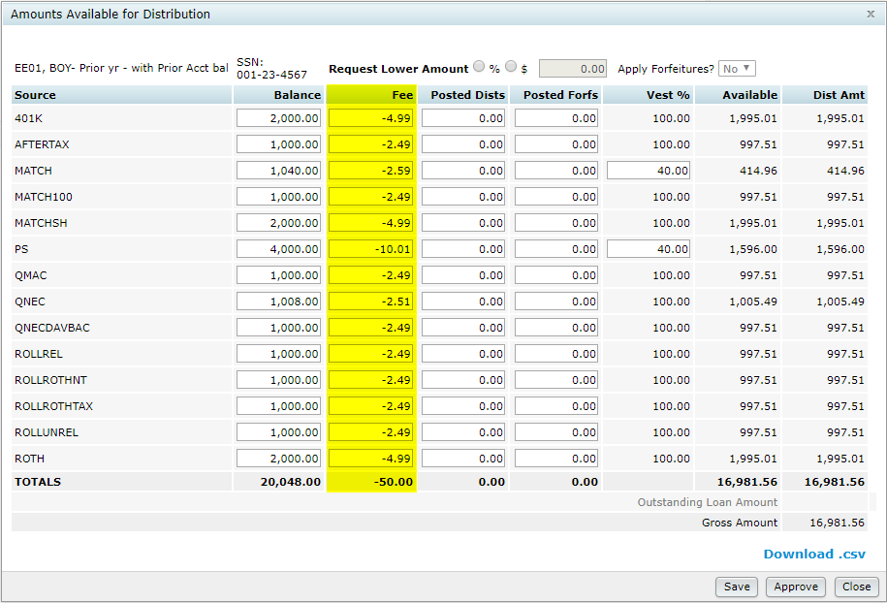

Posted Dists looks for any prior Distribution, Inservice, Hardship or LoanDef transactions for the participant. You may edit these fields if you have not posted all the necessary transactions. You will need to edit these fields if the participant has previously taken a full distribution to exclude the prior amounts that do not apply.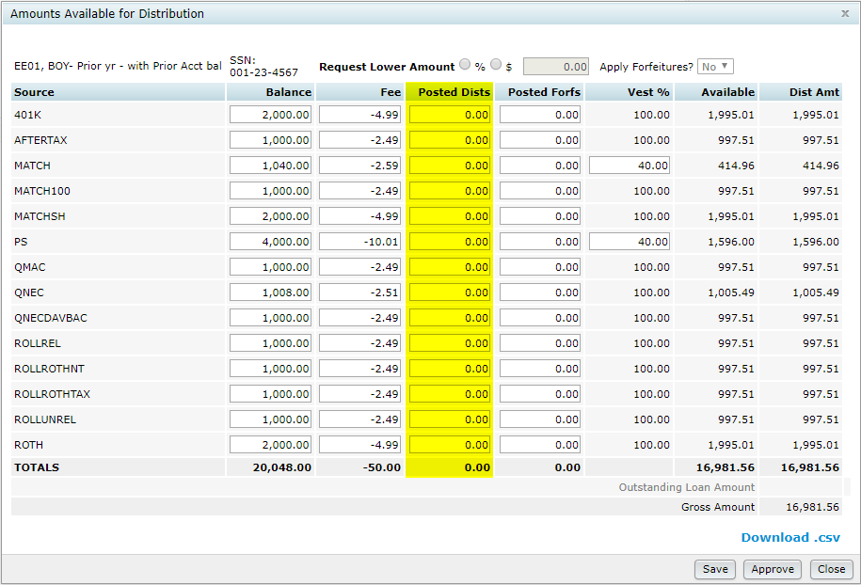

Posted Forfs looks for any prior Forfeiture transactions for the participant. You may edit these fields if you have not posted all the necessary transactions. You will need to edit these fields if the participant has previously taken a full distribution to exclude the prior amounts that do not apply.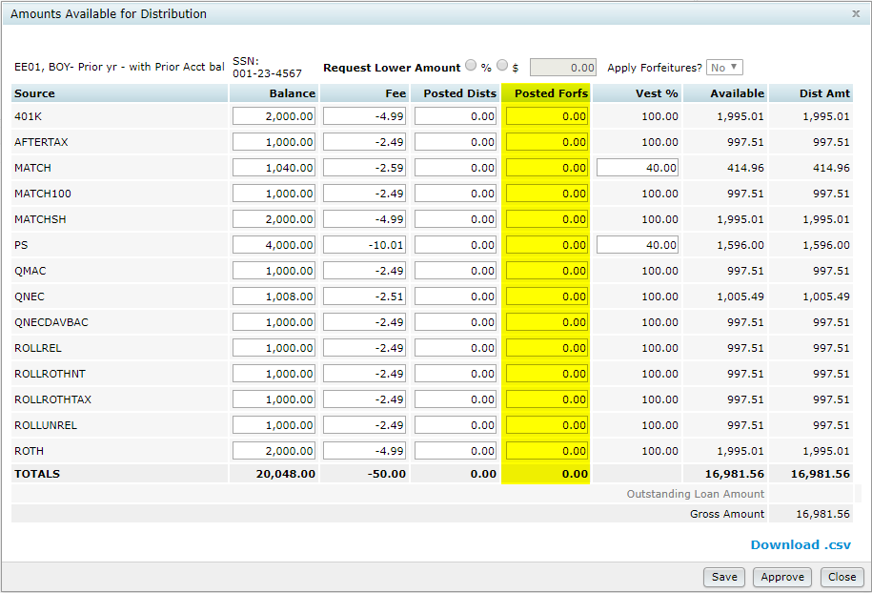

Vest % is updated based on years of service and the vesting schedule assigned in the Plan Specifications for the source. You have the ability to edit any source that uses a vesting schedule other than 100%. This data is not stored in the participant master. If you need to change years of service you will need to use another method.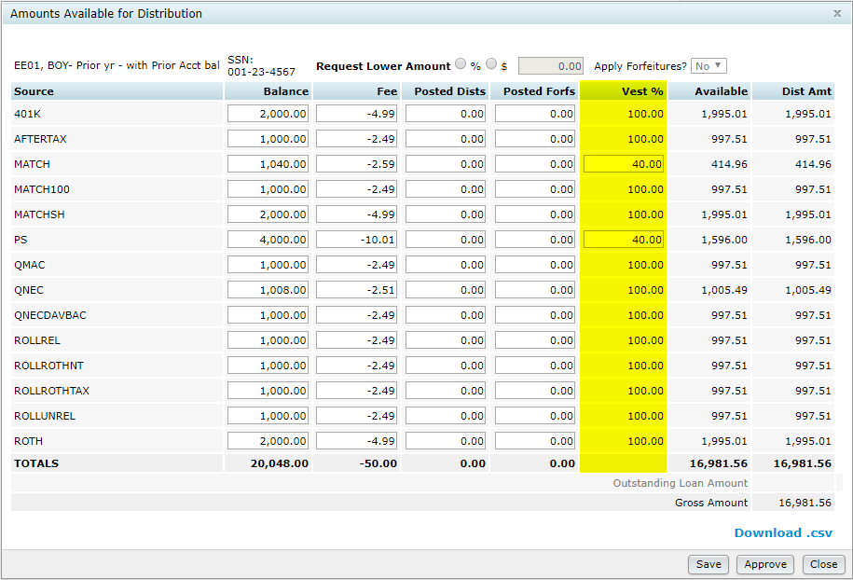

Available is a calculated amount using the prior columns and also taking into account any defaulted loans from a loan source or investment. If your plan uses the loan feature or a loan source, those will appear on a row in this screen and can be edited to affect the amount available. Loans will always appear at 100% vested and will not be available for distribution. However, loan amounts will be used in the calculation for the amount available for the other investments/sources in order to calculate an accurate vested balance. We made them visible for verification purposes. Loan defaults will be processed based on the Outstanding Loan Amount. It is crucial to have the loans be accurate prior to processing.
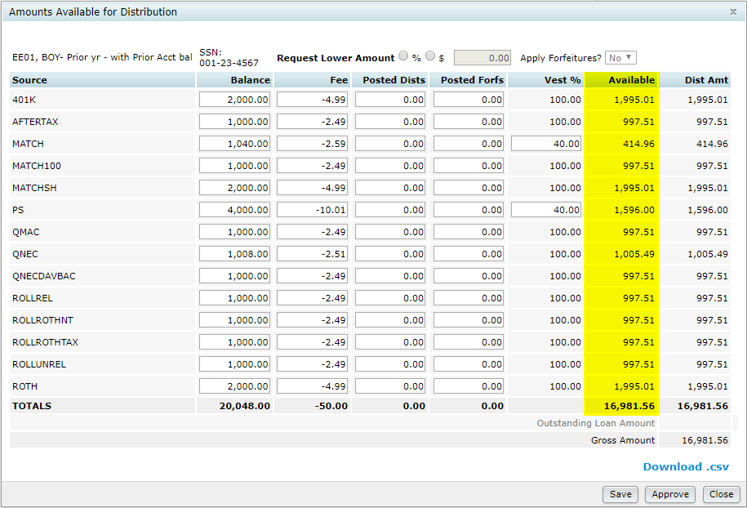

You can request a lower amount by % or dollars by selecting the appropriate radio button.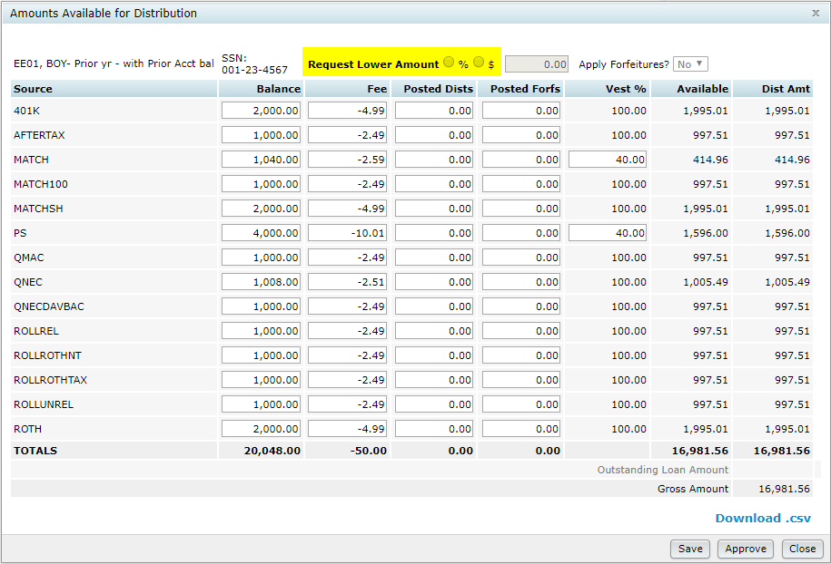

When you select one and enter the appropriate amount in the field, the Dist Amt automatically recalculates based on your selection by using the amount available. If your plan uses ordering, the Dist Amt will be applied accordingly when a lower amount is requested.
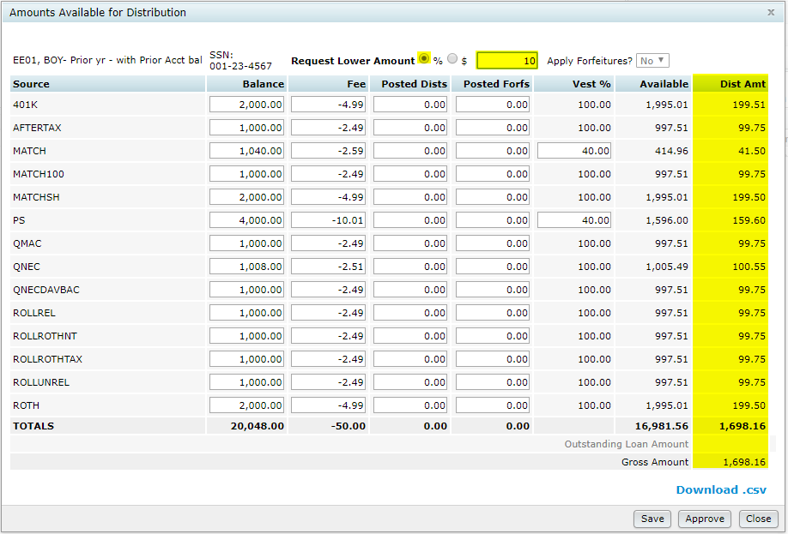

Since this is an In-Service/Partial type, the ability to apply forfeitures does not apply. However, in the case of a Distribution type, this field defaults to Yes. You may change it to no if your plan does not accommodate forfeitures at the time of distribution. When it is Yes, a column will appear after Available that will reflect the current forfeiture amount and a Forfeiture transaction batch will be created.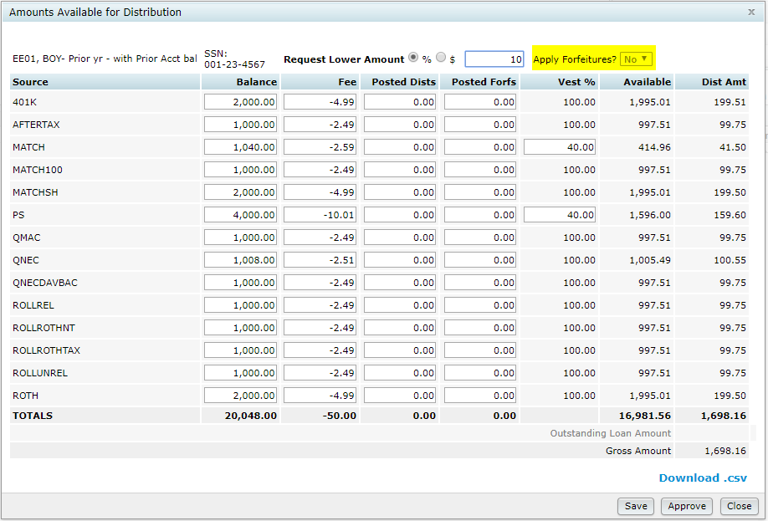

Because we are working with and In-Service/Partial Outstanding Loan Amount is not available. However, in the case of a Distribution type, since loans are able to be defaulted upon a distributable event, the outstanding loan amount would show and the field is able to be edited. An amount in the field will generate a LoanDef transaction batch.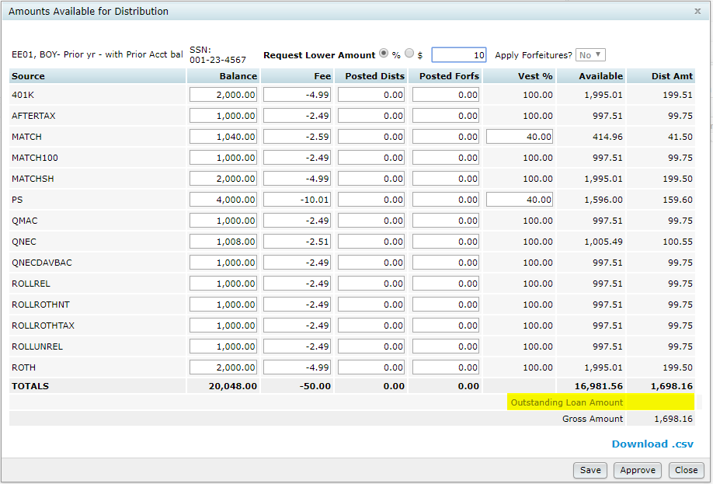

Gross Amount is the total of investments and the Outstanding Loan Amount.
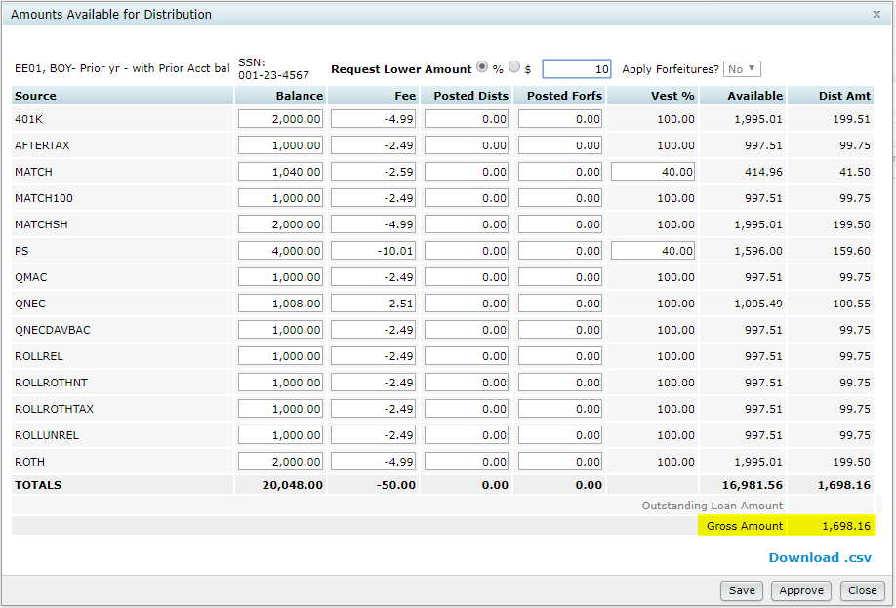

Download.csv will allow you to download a .csv with all of the information from this pop up. 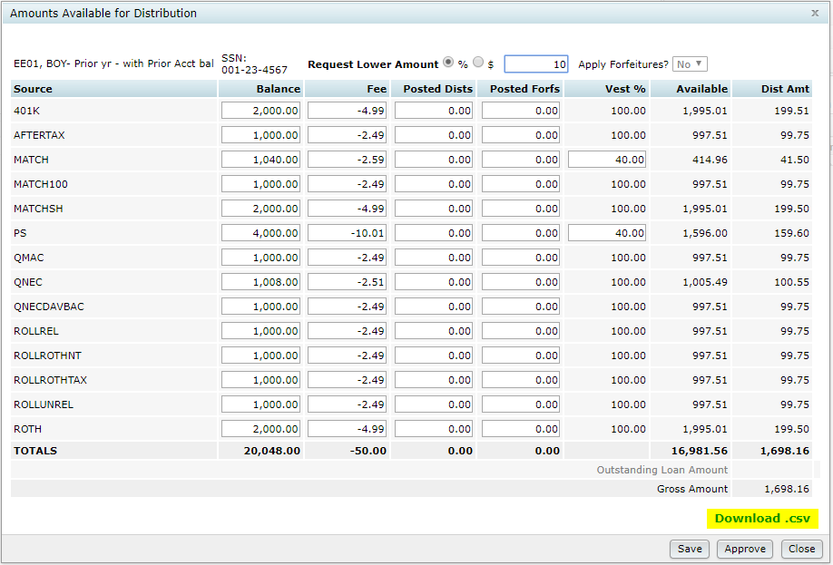

When you have finished reviewing the balances and are satisfied they are correct, you can select Save if want to come back to review again need approval by another user or Approve if no review is necessary.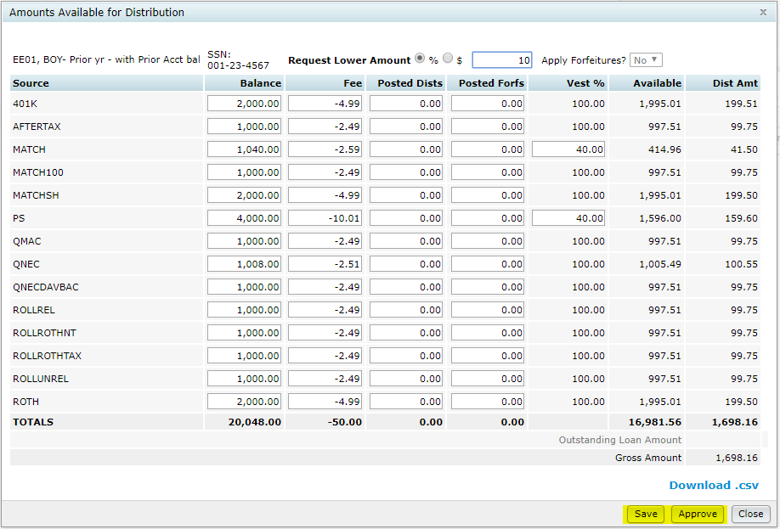

For this example, I will approve the amount. 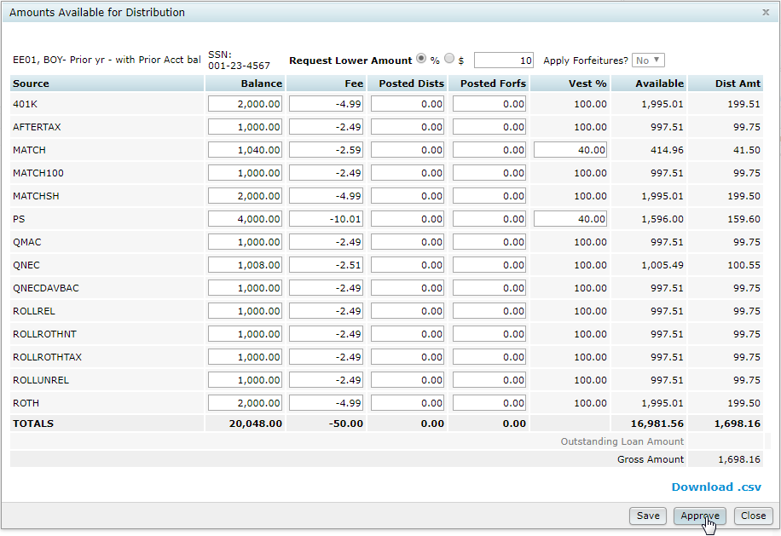

You will receive a message letting you that you will not be able to make changes to the distribution after approving. If you select No, you will be returned to the Amounts Availalbe to make additional changes or save it. Selecting Yes will bring you back to the Distribution Data where you can select Add Transactions and lock the record for editing.
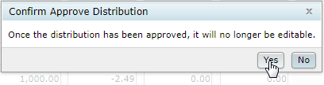
Then select the Add Transactions link. 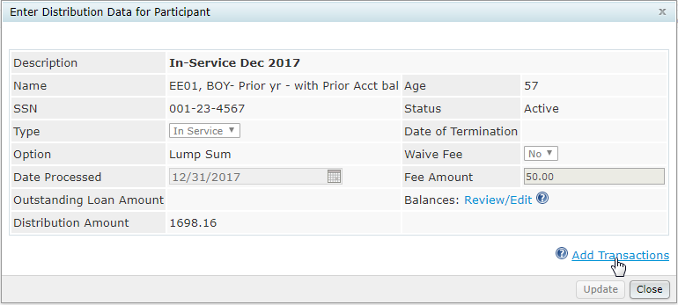

You will receive a message to confirm that you wish to add the transactions. If you select No you will be directed back to the previous pop up where you can review the existing numbers or close out and return to the Distribution main page. We will select Yes.
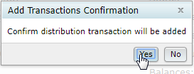

You will receive a confirmation message letting you know how many batches were created. For this distribution we only expect two. One for the Inservice transactions and one for the Fees. If you select OK you will be directed to the Distributions main page. We will select Go to transactions.
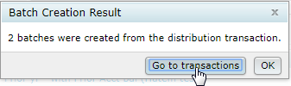

You will be directed to the transactions page where you can review the batches created for your request. We have added the name and description information to the batches to make them easily identifiable. From here you can review the batches and post them. You will need to run the statements or participant summary to save the posted amounts in the system and be sure the amounts are correct for future distributions.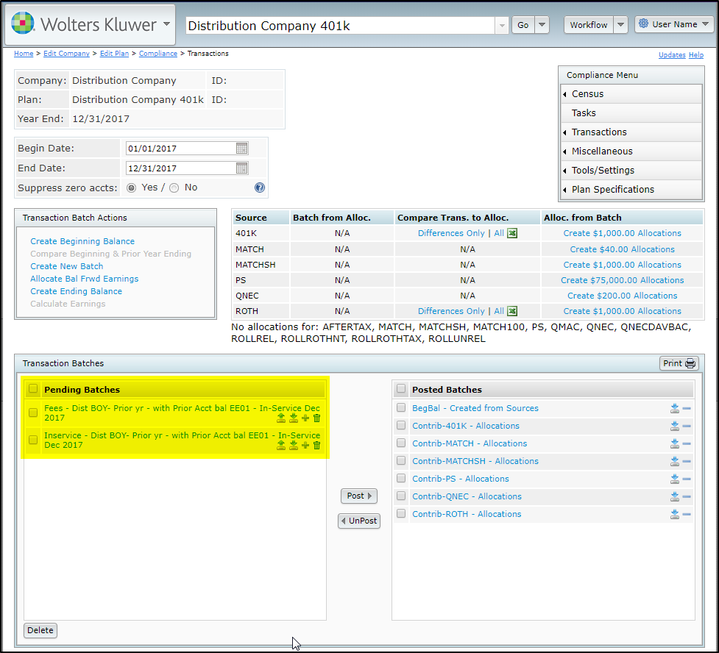

Navigate back to the Distributions page where you can see the distribution is now visible since transactions now exist either in Pending Batches or Posted Batches. If you were to select the trash can icon to the left of the record, you could unpost a posted distribution and delete the transactions. From here you can also review the distribution information in detail by selecting the description link. You can sort this report by clicking the column headers and filter by entering information in the box above the header item.
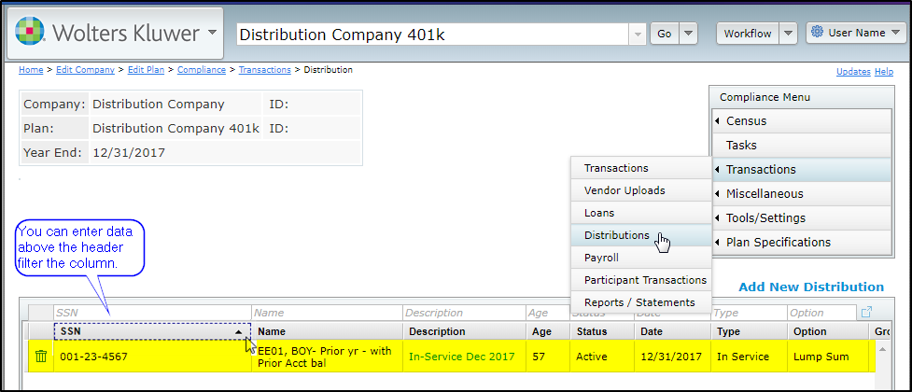

By scrolling to the right you can see more of the summary data. There is also an option to download the information from this page to a .csv file. 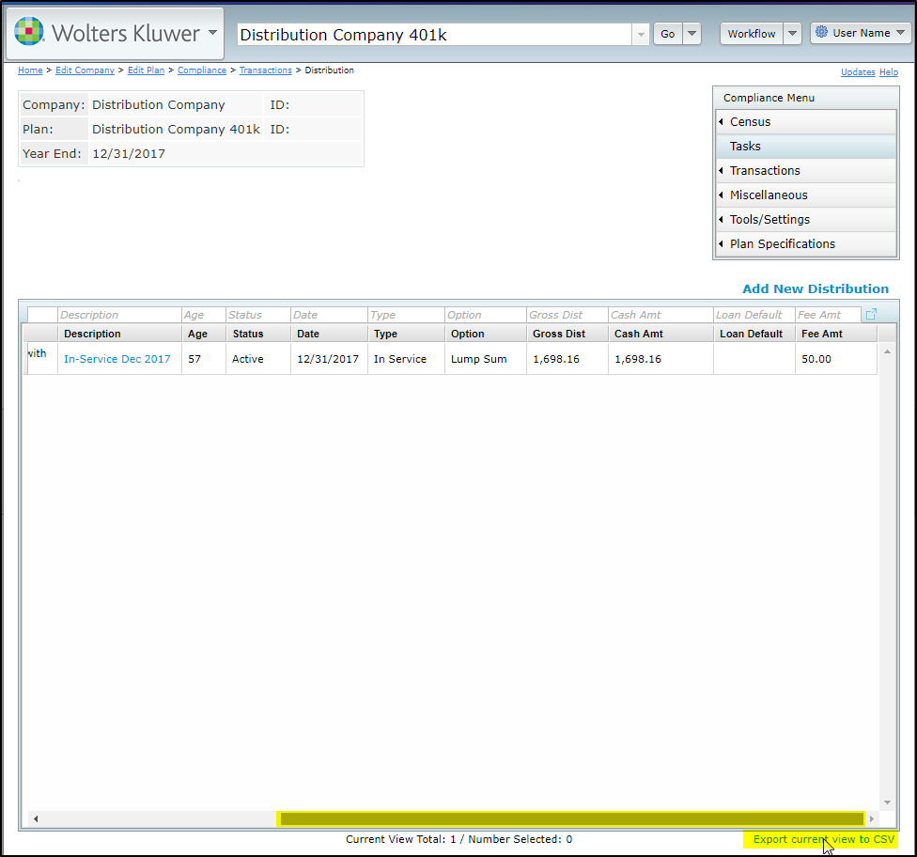

The distribution feature should ease the existing processing burden. We have other features to be released in the future and would appreciate your feedback on which features you find most useful and what you want to see added. There are plans to add 1099-R data and link it to the 1099-R module.

